**PROJECT ON DIGITAL MARKETING**

**NAME:**VIJAY V

**TEAM MEMBERS:**

YOGESHWARAN J

(34FBD181A13027FB5114052B006D5B2B) (**TEAMLEAD)**

VIJAY V(B8219507E118C91BE794EF8CAD2069BE)

VIGNESH S(8A2F32943D5A3389C784947A1267D6CE)

JEEVANANDHAM V (329B6ECFEBDE7C5B4124A12C14A7894E)

**TEAM NM ID:** NM2023TMID03449

**DEPARTMENT:** B.E COMPUTER SCIENCE ENGINEERING – FINAL YEAR

**COLLEGE: 8151-** DHANALAKSHMI SRINIVASAN INSTITUTE OF

TECHNOLOGY SAMAYAPURAM, TRICHY.

**NAANMUDHALVAN COURSE:** DIGITAL MARKETING

**PROJECT DESCRIPTION**

**PROJECT TITLE: CREATE A GOOGLE BUSINESS PAGE**

**BRAND NAME: HIFISECURITY**

**CATEGORY: SECURITY SERVICE**

**EMAIL:** [**hi5secure421@gmail.com**](mailto:hi5secure421@gmail.com)

**DOCUMENTATION:**

[**https://docs.google.com/document/d/1yihv10KpuKmK6KLiAmwUU1T_GIUPQg2t/edit?usp=drivesdk&ouid=112301930664915512541&rtpof=true&sd=true**](https://docs.google.com/document/d/1yihv10KpuKmK6KLiAmwUU1T_GIUPQg2t/edit?usp=drivesdk&ouid=112301930664915512541&rtpof=true&sd=true)

**RECORDED VIDEO:** [**https://youtu.be/ApoB8d--yXw?si=lo1KKXlsS4_IM-am**](https://youtu.be/ApoB8d--yXw?si=lo1KKXlsS4_IM-am)

**DOCUMENTATION:**

Creating business name :

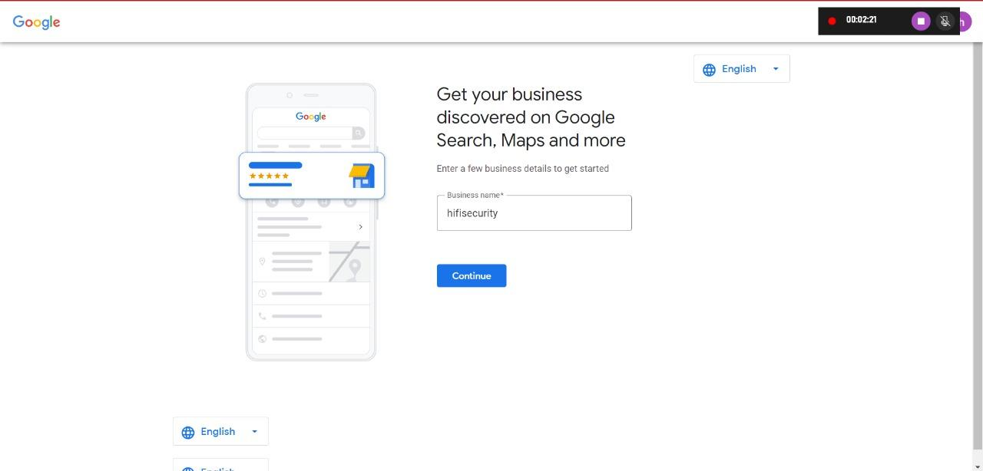

 Choosing business type:

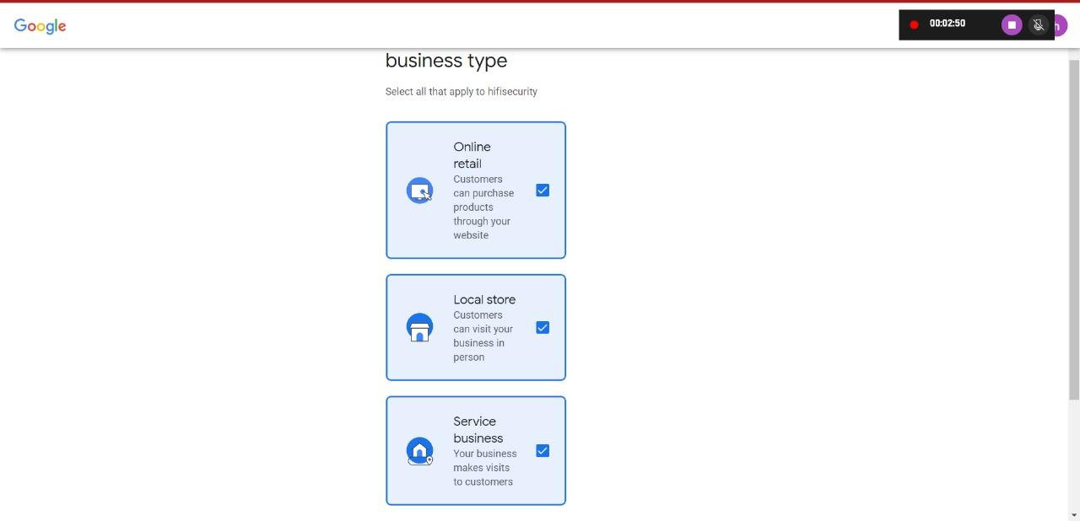

 Choosing business categories:

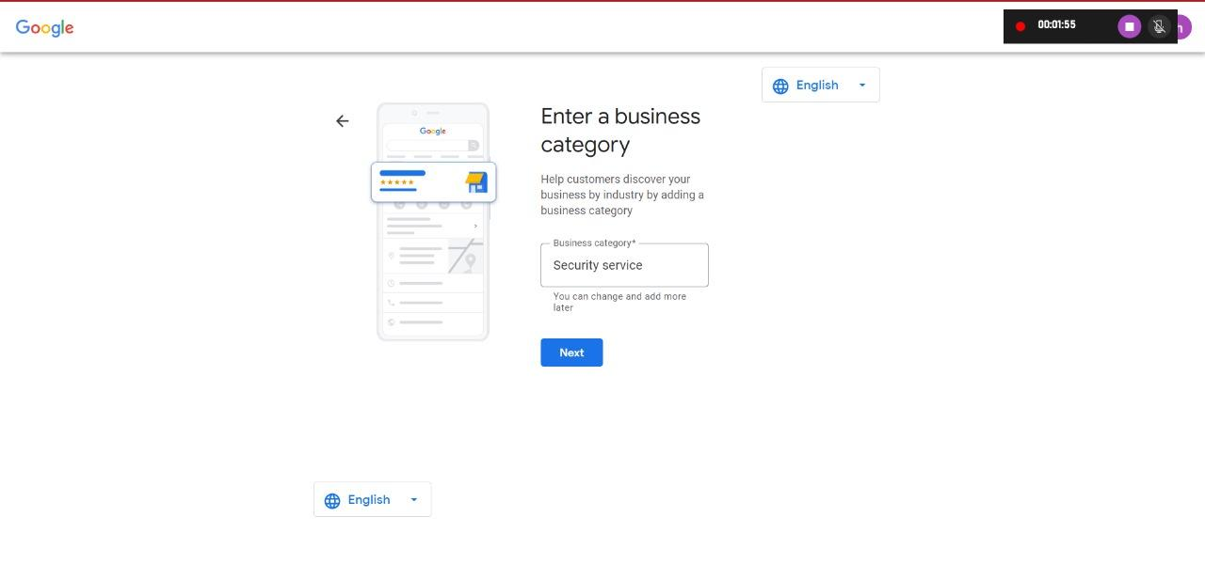

 Creating business address:

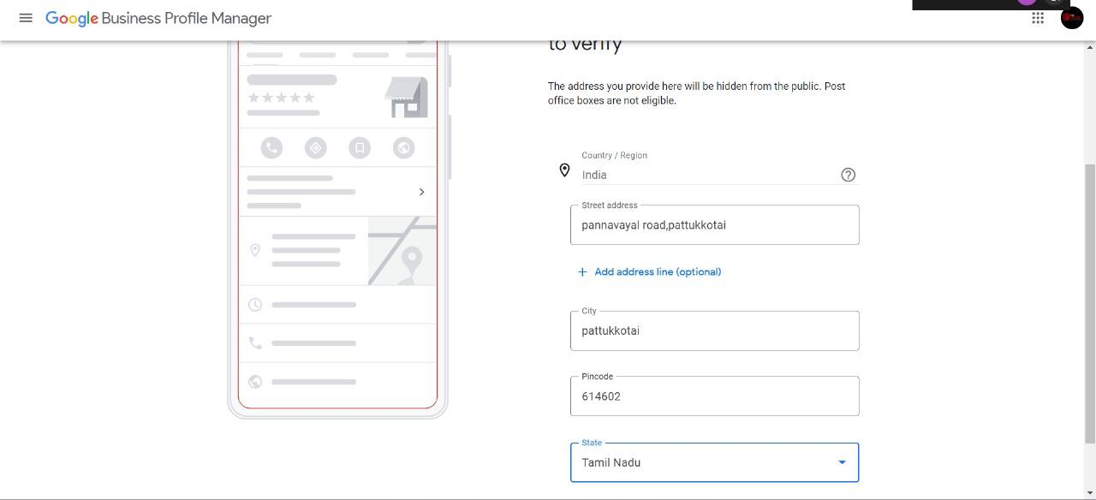

Getting verified:

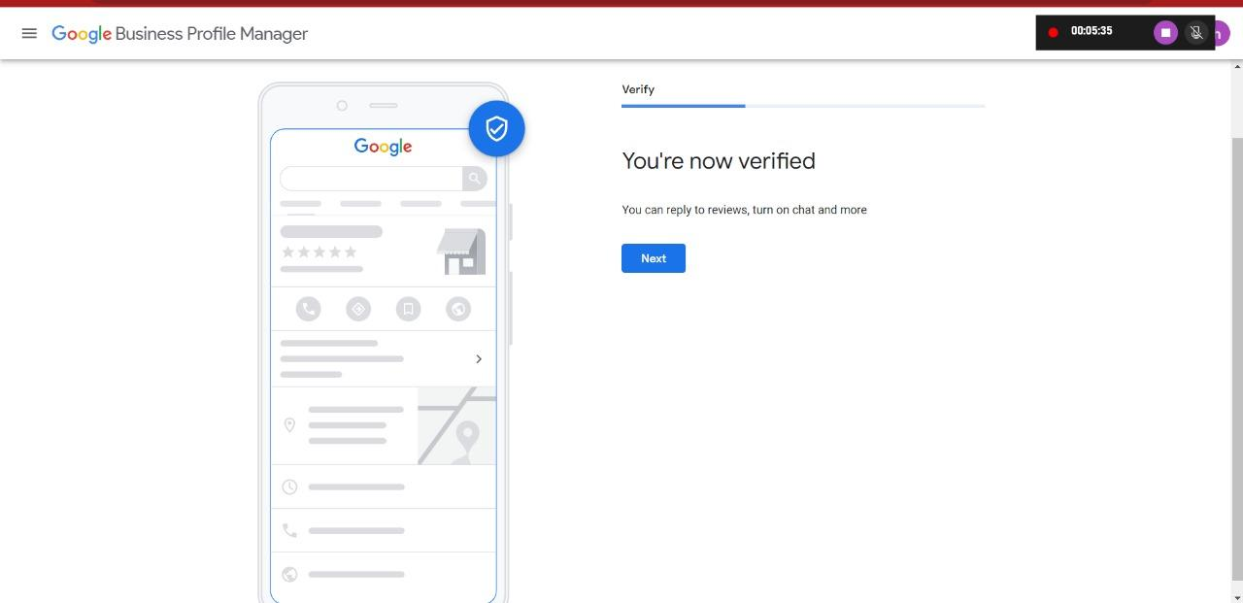

 Adding business description:

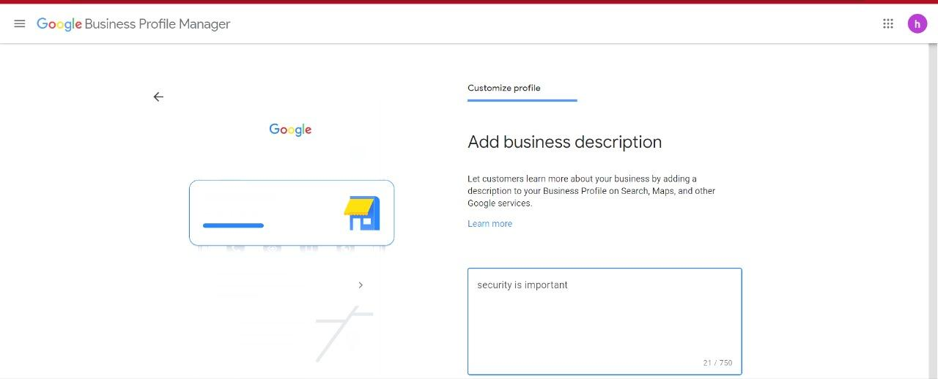

Claim business:

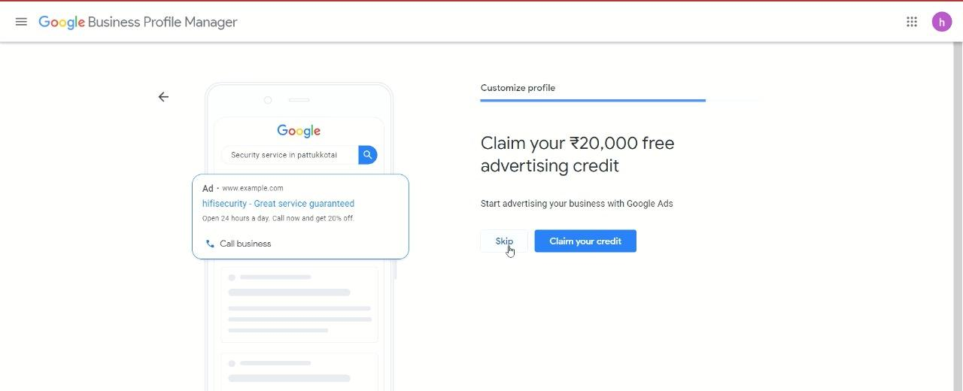

Visible information:

